4.3.1 Search Activity - Finding the patent document for the pop-up toaster
The best thing since sliced bread, but it was actually invented before sliced bread. See if you can find the application number, and locate the patent document of the pop-up toaster by Charles Strite applied for in 1920.
Step | Description of step | Model answer
1 | Choose a search site and indicate why you’ve chosen it. | We do not know the nationality of the inventor. Therefore we have chosen a multi-country database, ESPACENET, that is likely to go a long way back in time. http://worldwide.espacenet.com/advancedSearch?locale=en_EP
2 | Enter your criteria. | We enter strite, charles in the inventor field and find 19 patents. The most likely patent is US1394450.
3 | Find the original document that protected the toaster 100 years ago | The European Patent Office does not contain the original document. To get this you can go to the USPTO site, or search Google patents US1394450, and download the PDF copy of the original patent..  Change the coverage to 1790 to present [entire database]  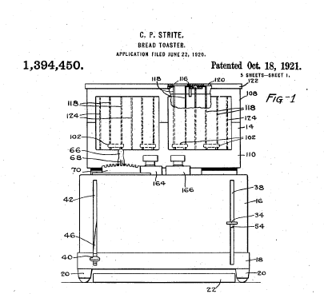  Note that there are two other toaster patents in the name of Charles Strite.

